**ANALYSIS OF SUPERSTORE GIANT SALES**

**Table of Contents**

* Introduction
* Business Tasks
* Exploratory Data Analysis
* Data Modelling
* Data Visualization
* Conclusion and Recommendation
* Appendix

**Introduction**

Superstore Giant is a company based in the US that deals in the sales of Furniture, Office Supplies and Technological products. They have multiple branches across the United States.

This Analysis was performed in order to assess how well the business is doing and to advise on areas that need to be improved.

**Tools Used**: Excel and Power BI

**Business Tasks**

With growing demands and cut-throat competition in the market, a Superstore Giant is seeking your knowledge in understanding what works best for them. They would like to understand which products, regions, categories, and customer segments they should target or avoid.

**Exploratory Data Analysis**

Data collection: The dataset was provided by Octave Incorporations

Data Cleaning: The dataset was in CSV format and the cleaning was done using Excel. The data contain 9994 records and 21 attributes. The order date and ship date columns were not properly formatted so I used the ‘Text to Column’ to convert them to proper date using the **mm/dd/yyyy** date format since the data is from USA. There were no duplicate rows neither were there any null values. There are 793 unique customers and 1850 unique products sold.

**Data Modelling**

I imported the data into Power Bi for proper visualization to be carried out and modelled the data into four different tables: Orders, Products, Customers and Territories. This was done in order to optimize the data and to reduce redundancy, then primary and foreign keys were used to create relationship between the tables.

I created a new table for Calendar and another table (DAX Measures) that holds all the new DAX formulas written to create measures so as to generate more insights from the data.

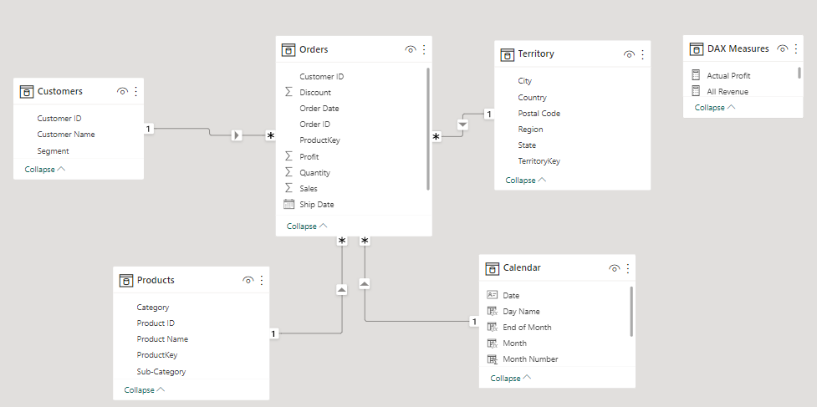

**Data Visualisation**

Here I started my visualization by answering the business questions using different visuals.

The company generated a total revenue of **$2.30M** and a net profit of **$286,409** leading to a profit margin of 0.12 which is totally small for a superstore of that size.

To dig deeper into the analysis to know why the profit margin is small,

I created a measure that showed the gross profit generated over the four years which amount to **$442,528** while incurring a loss of **$156,119** during sales over this year. This loss amount to 35% of the profits.

**Top 10 products by revenue**

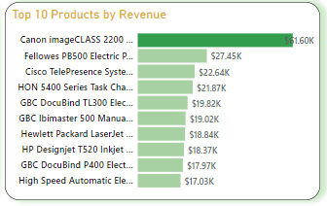

Canon Image class Advanced copier from the Technology category has the highest revenue of **$61,599**.

**Bottom 10 products by Revenue**

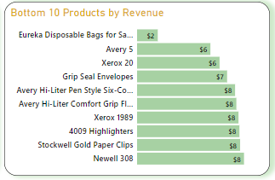

The bottom 10 products analysis above shows the least revenue generated are from the Office Supplies category with Eureka disposal bag topping the lists. This is likely due to the discount rate of 80% on this product as compared to other products.

**Revenue and Profit by Category**

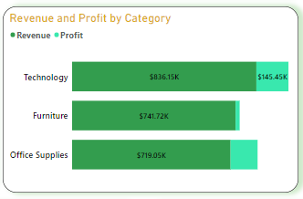

Products from Technology category generated the highest revenue ($836,154) and profit ($145,454) followed by Furniture with a revenue of ($741,748) and Office supplies which is ($719,047). Meanwhile, Office Supplies generated a profit of $122,490 which is higher than the profit generated by Furniture amounting to $18,463.

This shows that even though, the office supplies goods generated low revenue, they have more profits than furniture.

**Revenue by Customer Segment**

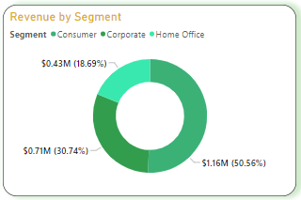

The Consumer segment with revenue ($1.16M) accounted for more than 50% of the total revenue followed by Corporate with revenue ($0.71M) while home office generated the least revenue of $0.43M.

**Revenue by Region**

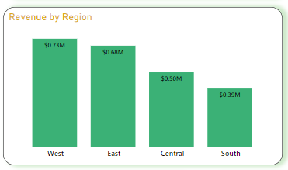

West region made a total revenue of ($725,457) and profit of ($108,418) followed closely by the East ($678,499), ($91,534) and the Central ($501,293), ($39,706) while South generated the least revenue ($391,721), ($46,719).

However, it is important to point out that the south generated more profits than the Central, with higher revenue.

**Top 5 states by Revenue and Profit**

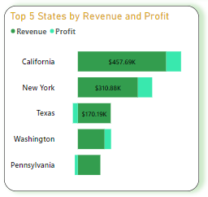

California, New York, Pennsylvania, Texas, and Washington are the top 5 states that generated the highest revenue contributing over 60% of the total revenue. It turned out that Texas and Pennsylvania ran at loss of (-$25,729) and (-$15,559) respectively.

A further analysis shows that the discount given in those states are way too much compared to other 3 states, this affected them and made them account for loss.

**Conclusion and Recommendation**

It is not enough to make sales, as it is also important to generate profit, this has been displayed in two occasions when we saw some states such as Texas and Pennsylvania topping the list of states with highest revenue but generated no profit. Also, in the product category where Office supplies generated the least revenue but was relatively better in terms of profit made than furniture. Hence the company should not only focus on making sales but also to generate more profits.

The Profits generated by the company was greatly affected by the loss incurred on sales. It is advised that discount on products should not be more than 25% as it was seen in the west region that they only give discount between 0%-20% and thus generated higher revenue and profits. Discount above 30% on products always lead to loss, as seen in Texas and Pennsylvania where a discount in the range 30 - 80% was given. Hence, the company should cut down on giving discounts on products as to increase the profits.

The bottom 10 products with least revenue are not doing totally bad after all and should not be discarded as further analysis showed that they are generating positive profits so it is recommended that the company gives little or no discount on them.

Although all customers segments are doing well, the Consumers segment should be targeted more as they contributed over 50% of the company’s revenue.

Summarily, Superstore giant issue is largely dependent on the discount given on their products. Resolving this, a lot of their products, regions, and category will drive more sales and the profits would increase significantly.

**Appendix**

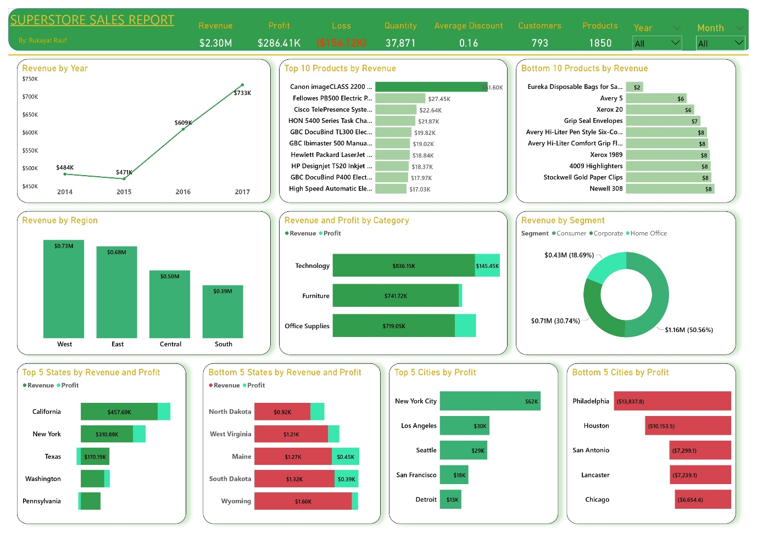

Link to the full report on medium: <https://medium.com/@raufrukayat/analysis-of-superstore-giant-sales-dc7d0aa5a500>

Interactive dashboard: <https://app.powerbi.com/view?r=eyJrIjoiYzYxNmU3MzgtZjE4OC00MTUyLTk5NzMtNDk5ZjYyZGQyMTEzIiwidCI6IjExODg4MzNmLTRiMTktNDYzYS04OThmLWM2ODMxNmRjOTQ1NiJ9&pageName=ReportSection>